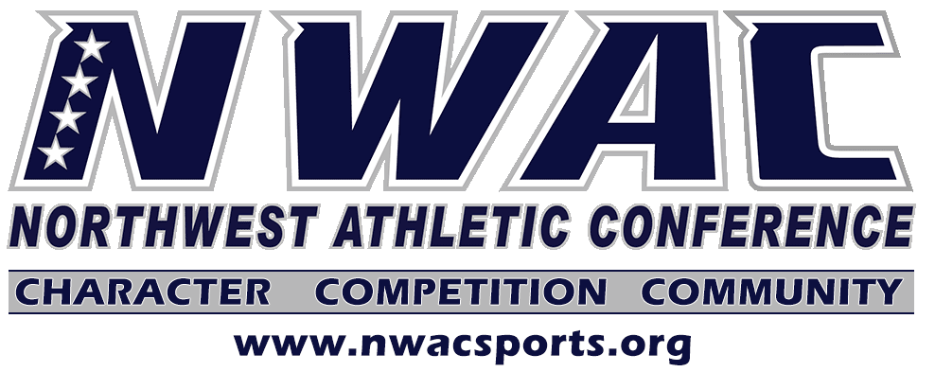

VACCINATION/SAFETY UPDATE
7.23.21

Executive Summary
As the Northwest Athletic Conference (NWAC) looks to transition from 2020-2021 to the 2021-2022 season, the conference has constructed a set of guidelines to be followed by NWAC institutions in our desire to compete in 2021-2022. These safety guidelines as much as possible try to reflect the ever changing environment of COVIVD-19.

With 36 community colleges located in three states and two countries, requiring vaccination against COVID-19 for either on campus instruction or participation purposes varies greatly among our member institutions. It is our understanding that member colleges will provide waivers to faculty, staff and students based on individual circumstances as determined by the institution. As a result, the NWAC will not mandate vaccinations in order to participate in intercollegiate athletics as a conference policy. However, individual schools retain the right to mandate vaccines on their own campus for on campus instruction or participation purposes but cannot mandate another conference school do the same.
Over the past couple of months NWAC has provided (on at least two occasions) our member colleges with conference plans for participation and competition for the 2021-2022 year (see attachments). In short, teams with 70% of its members/coaches vaccinated will not have to partake in testing protocols. Non-vaccinated individuals will maintain all protocols.
According to the Center of Disease Control (CDC), state and local health authorities, vaccines have proven to be quite effective when people are fully vaccinated. Vaccinations provides the NWAC opportunities to maximize our opportunities of returning to a normal collegiate experience.
Oregon Health Authority (OHA) states that vaccinations remain the safest and most effective way to prevent serious illness from COVID-19 and all of its variants. If fully vaccinated, people are well protected from COVID, including the Delta Variant.
Oregon Health & Science University (OHSU) lists the following facts about COVID vaccines:
*Vaccines keep people from going to the hospital or dying because of COVID-19.
*Side effects are usually mild to moderate, lasting only a day or two.
*Vaccines can’t track you, affect your DNA, damage your fertility or give you COVID-19
*Getting a vaccine is especially important for people of color.
*Vaccines are safe. They were tested in tens of thousands of people, including people of color.
*Vaccines contain no fetal tissue or fetal cells.
Earlier this week the CDC reported that 93% of people admitted to hospitals due to COVID are unvaccinated.
Current guidance from the CDC is there is no evidence that the vaccines cause fertility problems. The American Society for Reproductive Medicine (ASRM) recommends the COVID-19 vaccine to those who are pregnant or plan to become pregnant, to minimize COVID-19 infection risks to themselves and their pregnancy.
FAQ’S

1. If a team cannot reach the 70% threshold because individuals are exempt from vaccination what happens?
A. Vaccinated individuals do not have to test and non-vaccinated individuals will maintain all protocols.

2. Those who will be tested when do their results need to be confirmed?
A. Results need to be confirmed prior to the team leaving for a contest. No person with unconfirmed results is allowed to travel or participate in contest.

3. A volleyball team has 72% of their team (student-athletes/coaches) who are vaccinated. Does that mean the whole team does not have to wear a mask in practice?
A. Vaccinated members of the team do not have to wear masks. Non-vaccinated members of the team must wear masks per institution policy. Though institution policy may be stricter.

4. A basketball team has less than 70% of their team (student-athletes/coaches) vaccinated does that mean that all members have to wear masks?
A. No. Only the non-vaccinated members of the team have to wear masks. Though institution policy may be stricter.

5. A soccer team has less than 70% of their team (student-athletes/coaches) vaccinated and a team member tests positive for COVID. Does the whole team have to quarantine?
A. Per current CDC recommendations vaccinated individuals do not have to quarantine unless they are symptomatic.

6. Does each student-athlete have to have a new physical for 2021-2022?
A. It is recommended that your sophomores get an annual physical, as things may have changed within the academic year. You should require anyone previously testing positive from COVID-19 to have a physical and have their heart and lung function tested. (Section 6 of COVID Manual).

7. Are those (student-athletes/coaches) individuals who have an exemption from the vaccine exempt from all safety protocols?
A. No. The exemption precludes them from the vaccine but not the safety protocols (i.e. facial coverings, social distance, quarantine, etc.)

8. Are the NWAC phased return to sport protocols in effect for 2021-2022?
A. Yes for non-vaccinated individuals, vaccinated individuals do not have to go through the phases. Grey phase is seven days and the red phase is no longer required.

9. A vaccinated men’s basketball player goes home to Colorado during the Christmas break and upon returning back to campus does he have to quarantine?
A. No, there are no travel restrictions for fully vaccinated individuals.

10. An unvaccinated women’s basketball player is on a team that has met the 70% threshold and she goes home to Chico California during the Thanksgiving Break. Upon returning back to campus, will she have to quarantine?
A. Yes, she would have to quarantine for at least seven full days after travel.

11. NWAC member college A is traveling to NWAC member college B for a game. The athletic administration from school A does not have to inform athletic administration at college B whether or not school A’s team has or has not met the threshold.
A. False. The two school athletic administrator’s or designee must inform each other at least 24 hours in advance where each team’s status is regarding the threshold.

12. If a student-athlete gets their first shot when they arrive on campus August 1, do they have to follow the seven day quarantine?
A. Being fully vaccinated means two weeks after the final dose.

FOREFEITURES/NO CONTESTS
NWAC contests canceled due to a COVID-19 outbreak on a team before a scheduled game will not be rescheduled. When a schedule game is terminated before it begins due to COVID related issues and one team cannot field a team, the game is recorded as a no contest. The team that was able to play is credited with a win.

