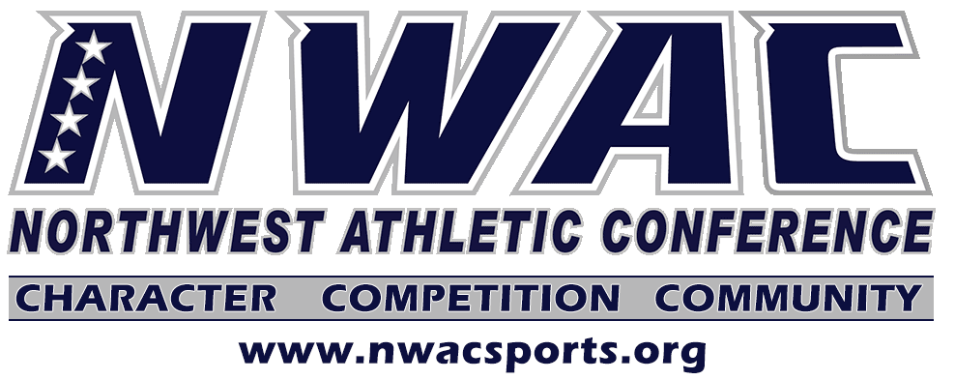

ELIGIBILITY PETITION WAIVER CHECKLIST
Complete NWAC Eligibility Form.
Provide copies of official transcripts from all colleges attended.
Provide statement from student-athlete expressing why the waiver should be waived.
Optional but beneficial: Statement from athletic staff supporting the request (transfer, dual enrollment, void LOI, etc.).
Required: Tracer for transfer student.
Send all materials into the NWAC office at the same time. Incomplete packets will not be reviewed.

MEDICAL HARDSHIP WAIVER CHECKLIST

Complete Medical Hardship Waiver Form.
Medical Hardship requests will be accepted between the conclusion of the current sport season and the start of the following sport season.
Required: Provide a written statement from the doctor who evaluated the injury. Only a doctor’s statement is allowed.
Provide copy of official updated transcripts of all schools attended.
Provide an official school schedule indicating the dates of the games the student-athlete participated.
Provide documentation of injury or illness from coach or school personnel specifically explaining what transpired.

